**Asian Hornet Fact Sheet**

* A single Yellow-Legged Asian hornet queen arrived in France around2004, an accidental import from China

* The insect has since invaded many parts of Western Europe
* They were first discovered in the UK in 2016
* Between 2016 and 2022 there were 23 confirmed sightings in the UK, including 13 nests
* In 2023 there were 72 nests found in 56 locations – more than the previous six years combined
* A voracious predator which poses a significant threat to honey bees and all native insects – it has no natural predators in the UK
* An average nest can consume over 11kg of insects in one year
* It has already altered the biodiversity in France, where it is present
* Their habit of hovering outside the hive stops the bees from collecting nectar and pollen to feed themselves
* Can now be found in 12 European countries
* Some make their way to the UK by flying across the channel – other routes include via ferries, containers and vehicles
* We need eyes on the ground everywhere – in towns and cities, parks and woodland areas…. ports, marinas, garden centres, orchards, vineyards, parks, timber yards, fruit and veg wholesalers, transport hubs and gardens need to be extra vigilant.
* Yellow-Legged Asian hornets have been found on ferries, sailing boats, and in imported goods such wood, soil and other horticulture products.
* Sightings should be reported, complete with an image if possible, via the Asian Hornet Watch app - available on app store for Android and iPhone
* The National Bee Unit (NBU) will then follow up reports and destroy their nests
* A single hornet is unlikely to cause injury if left alone
* They can become very aggressive if their nest is disturbed – keep a distance of at least 10 metres away
* The Yellow-Legged Asian hornet is a ‘reportable’ pest – if spotted, it should be reported to the National Bee Unit as soon as possible via the app
* The first confirmed sighting in 2024 was on 11th March, found in a potting shed at Ash, near Canterbury in Kent – a month earlier than the previous year
* Asian hornets have a stinger up to 3.5mm long, and they can use it multiple times
* Primary nests are roughly 5 -10 cm in diameter. These can often be found in

sheds, garages, porches, bird boxes, hedgerows and brambles, even vehicle engines – generally at a height of less than 10m

* Secondary nests will be built close to primary nests, usually within a distance of 100m. These are usually found in the tops of trees, but those built lower down are a danger to those who might accidentally disturb them; for example those in hedges, bramble patches, utility boxes etc. They can be very difficult to spot when concealed by vegetation.
* One nest can produce 350+queens, some of which will begin new colonies the following year.
* Asian hornets present one of the biggest threats to UK honey bees and other pollinators in a generation
* Not to be confused with “*Vespa mandarinia”*, the Asian giant hornet, aka ‘murder hornet’. This, to date, has never been found in Europe.
* All our efforts are currently working towards eradication. **Sightings should be reported via the Asian Hornet Watch app – QR codes below**

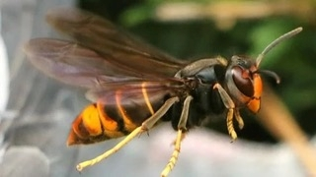

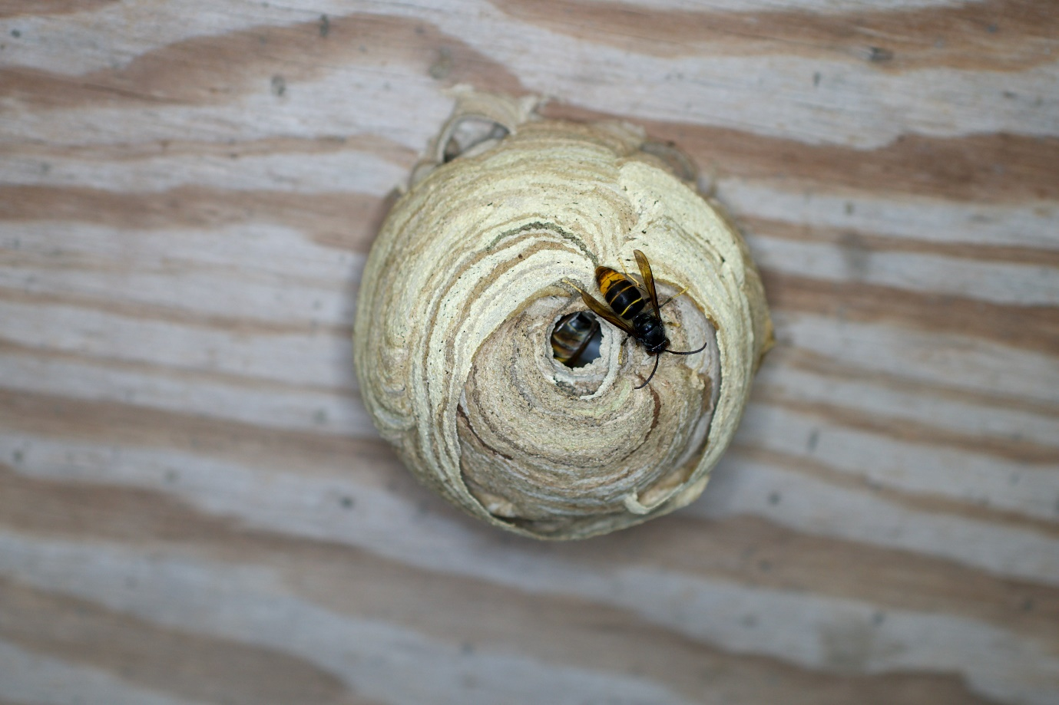

PRIMARY NEST (Credit – John De Carteret)

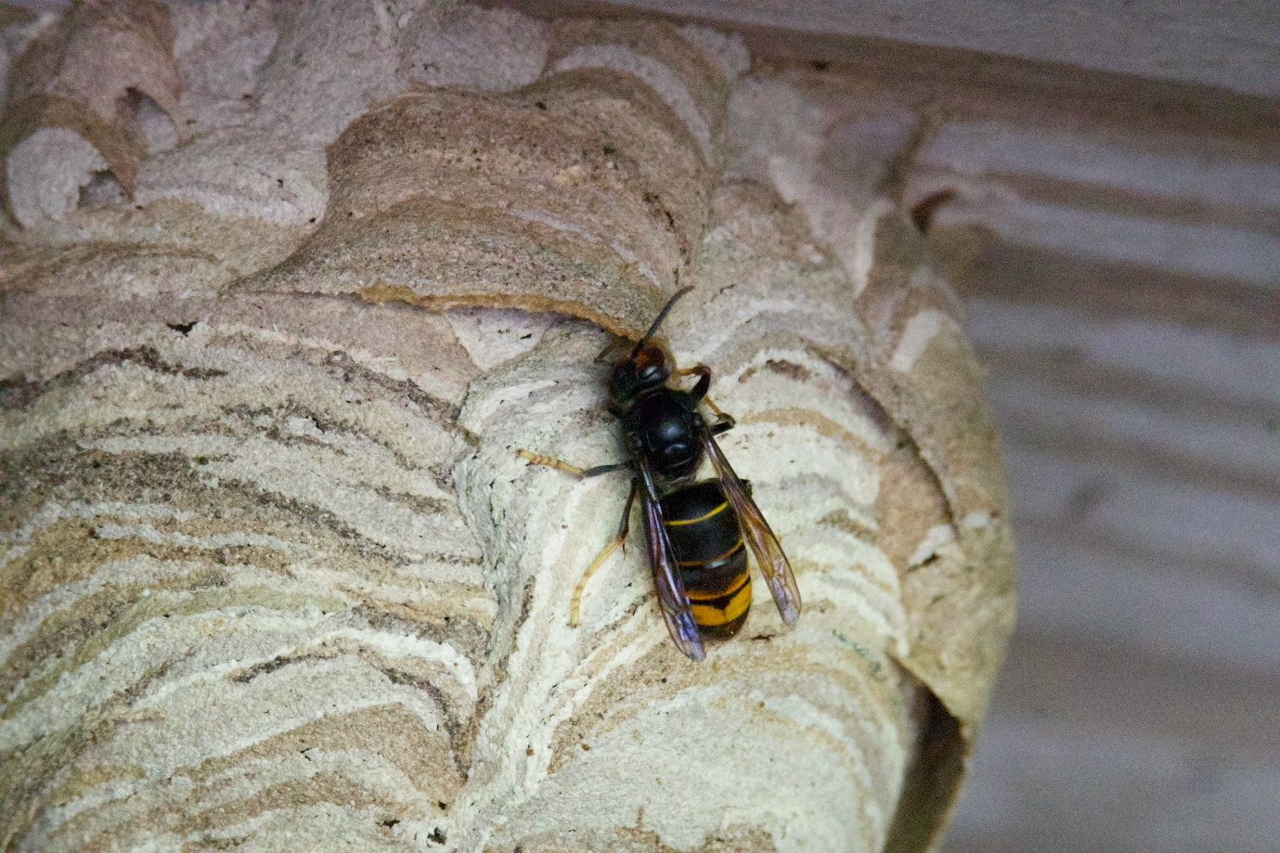

(Credit – John De Carteret)

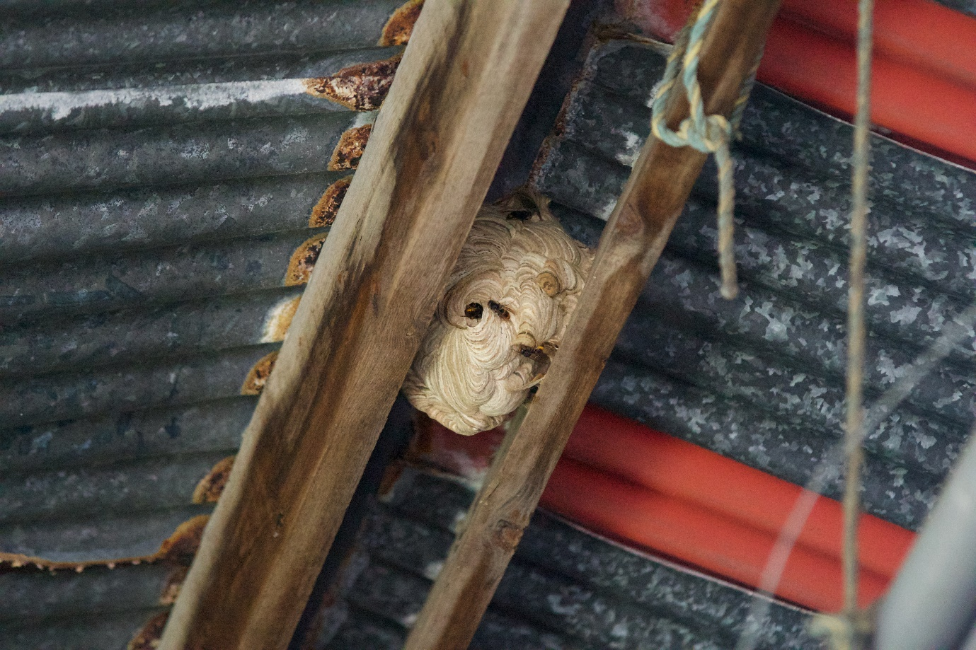

PRIMARY NEST (Credit – John De Carteret)

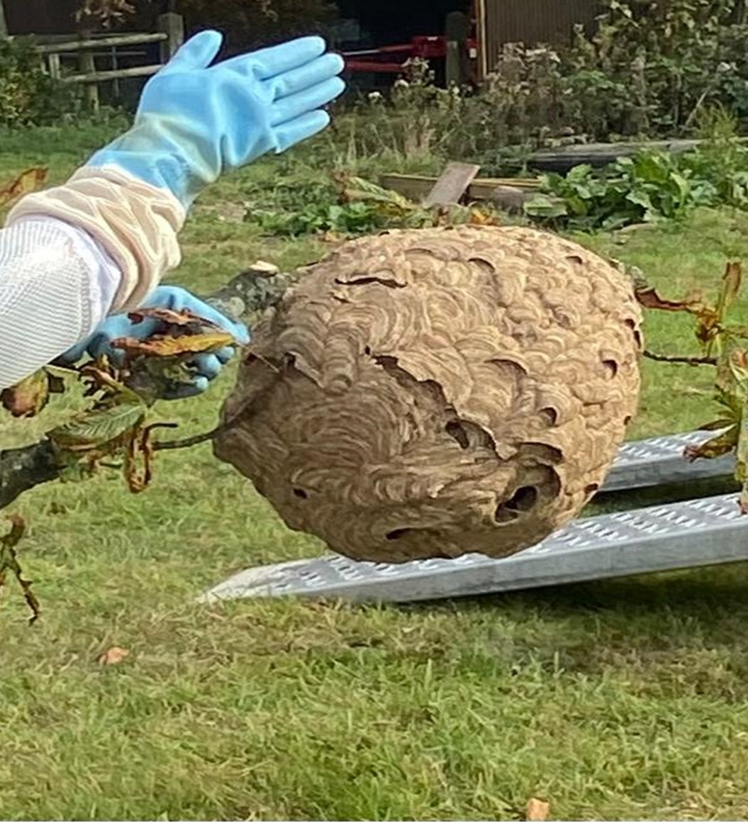

SECONDARY NEST (Credit – Donna Crum)

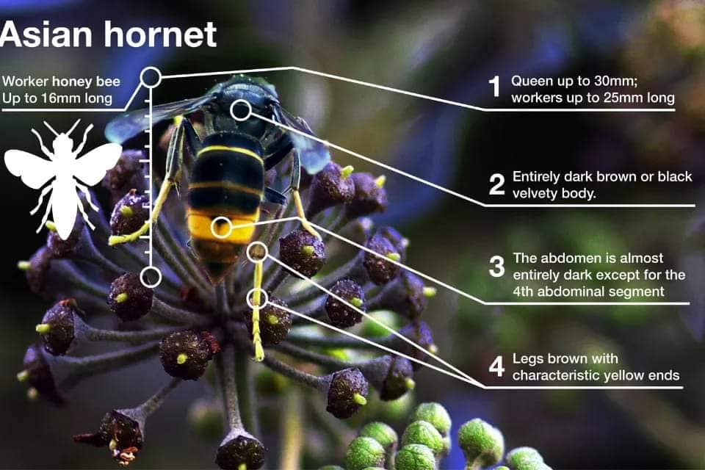

Credit: Non-Native Species Secretariat, Animal Plant and Health Agency

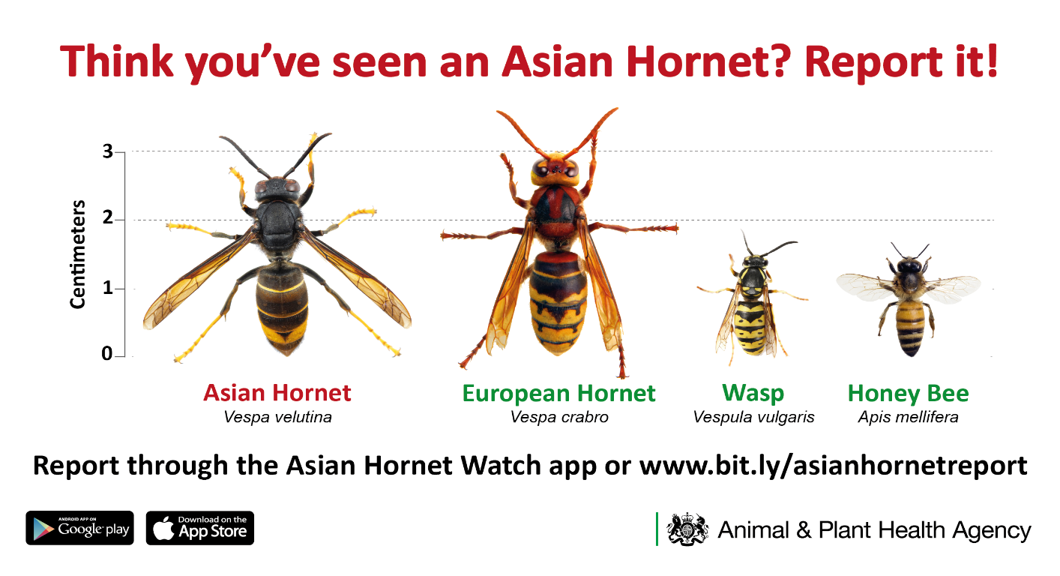



**Apple store**

**Google Play store**

**V1 2024**