**ASIAN HORNET SAFETY GUIDANCE**

**How to identify the Asian Hornet:**

The key identifying features of Asian Hornets are:

* BODY - generally dark in colour, black/dark brown
* REAR - key feature is dark brown with a distinct yellow/mustard band.
* WAIST - fine, bright yellow 'belt'.
* LEGS - brown upper part with distinct yellow lower leg, in fact it is often called the ‘yellow-legged hornet’.
* HEAD - black head with orange/yellow face
* SHAPE - sleek, wasp/hornet-like as opposed bee-like, or fly-like, with large compound eyes.
* SIZE -  slightly smaller than the native European Hornet, but larger than the Common Wasp. Worker hornets measure up to 25mm, queens 33mm in length.

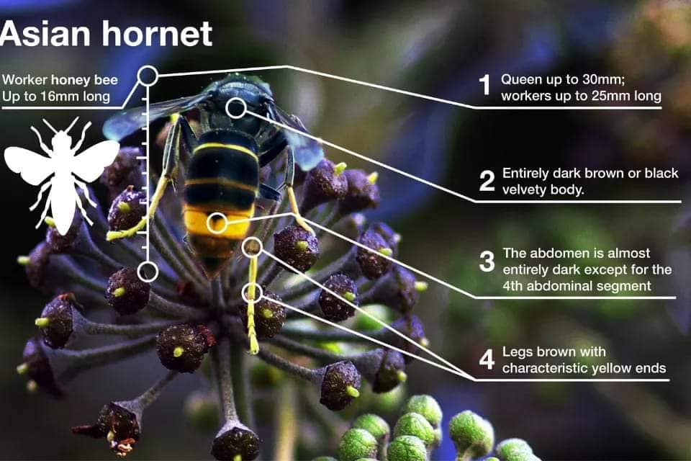 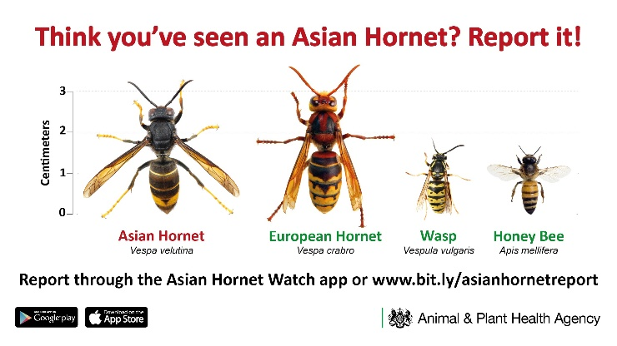

**Important guidance for outdoor workers**

This advice is for anyone working outside, commercially, or privately, and applies to gardeners, tree surgeons, farmers, branch age contractors, roadside maintenance personnel, parks and gardens staff, footpath and countryside maintenance personnel.

* Examine the area before you start work.
* Look for any unusual insect activity or anything that could be a hornet's nest.
* If you suspect unusual insect activity or a nest, stop!
* Stay at least 10 metres away and do not touch, disturb, or cause vibrations around a nest.
* Report any possible hornet or nest sightings to the [**alert_nonnative@ceh.ac.uk**](mailto:alert_nonnative@ceh.ac.uk), or on the **ASIAN HORNET WATCH APP,** with a photo if safe to do so.

Early in the season the nests may be the size of a tennis ball, and from late July the size of a football and larger, up to backpack size.

**Nests during early season** can be found in/at:

* Brambles
* Hedges
* Building and roof spaces
* Cliffs

**Nests during late season** can be found**:**

* Usually high up in trees.
* ….or all of the above.

They are usually well camouflaged amongst foliage and very difficult to see.

**What to do if you see an Asian Hornet or a nest**

**Asian Hornets:** Individuals do not tend to be aggressive. If you can, take a photo and send it in on the **Asian Hornet App** (QR codes below) or to [**alert_nonnative@ceh.ac.uk**](mailto:alert_nonnative@ceh.ac.uk)**.**

**Nests:** All suspected nests should be reported to the above addresses. You should never attempt to disturb, remove or treat them yourself. **Asian Hornets have been known to defend their nest area aggressively.**

**What to do in the event of an Asian Hornet sting**

Immediately move to a place of safety - one sting can lead to an aggressive reaction by more of the insects. Apply a cold compress or ice pack to the sting site. Elevate the sting area if possible. Avoid scratching.

**Symptoms**

* A sting will usually cause a red, swollen lump. This may be painful and itchy, but symptoms should improve within a few hours to a few days.
* Some people have a mild allergic reaction and a larger area around the sting may become swollen and painful.

Ask your pharmacist about painkillers, anti-itching creams and antihistamines.

Always seek medical advice if:

The sting is in the mouth, throat or near the eyes.

* Fever, swollen glands for flu like symptoms develop.
* Symptoms don't improve or get worse.

**Serious allergic reaction (anaphylaxis):**

Anaphylactic shock is a serious condition and urgent medical assistance should be sought. Symptoms and how to deal with anaphylaxis are on the [NHS website](https://www.nhs.uk/conditions/anaphylaxis/) - https://www.nhs.uk/conditions/insect-bites-and-stings/



Apple Store



NHS insect bites and stings advice

Google Play Store